New Graduate Student Quick Guide
Drafted August 2024 by Shyanne Lee, Josh Mirabela, and Brooke Propson
Revised September 2024 by Annalisa Stevenson, Mitch Wodrich, and Tanner Judd



Table of Contents:

- Meet the faculty
- Meet the building/staff
- New student resources and campus services
- Organizations for soil science graduate students
- Department seminar
- Funding and out-of-pocket expenses
- Reimbursements
- Benefits

1. Meet the faculty
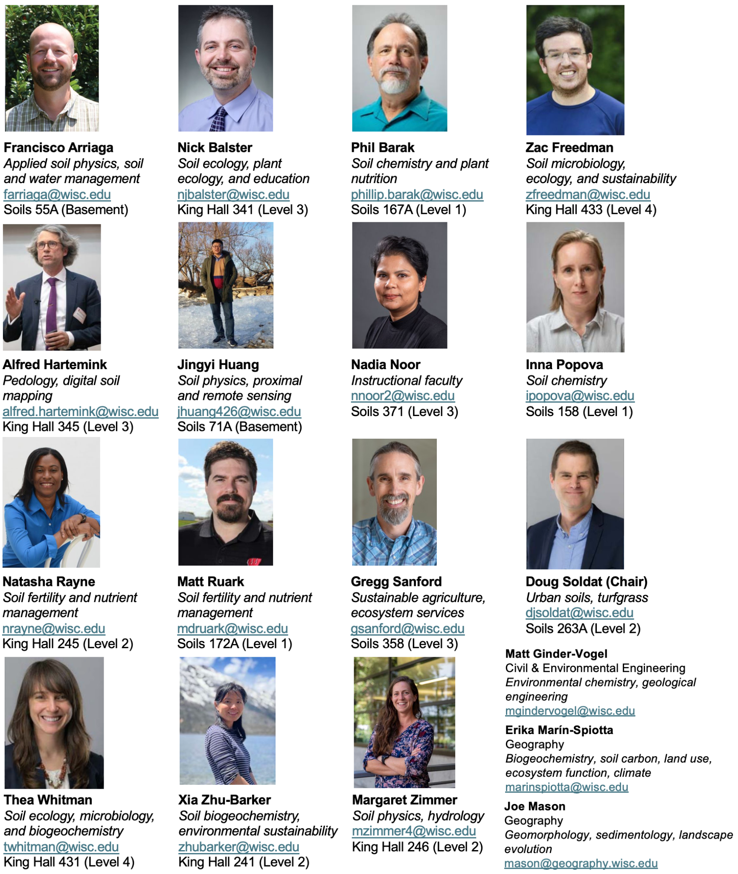
2. Meet the building/staff
- Main office - Room 263. So many helpful staff members as well as the department chair have offices in here, including:
  - Ryan Ihrke, 263 - Ryan is the department’s Financial Specialist and can answer questions about lab expenses and grants as well as general questions. He’s also the guy to go to if you need to borrow a key!
  - Julie Garvin, 263D - Julie is our Graduate Program Manager. She can help out with questions involving program requirements, enrollment, society memberships, and reserving classroom spaces.
  - Maddie Hoffman, 263E - Maddie is the Payroll and Benefits Specialist. Ask her if you have any questions about stipends, benefits, and student fees.
  - Matt Hahne, 263B - Matt is the Department Administrator for both our department and Biological Systems Engineering (BSE). In addition to handling the building’s spaces and resources, he’s a great person to ask if you don’t know who to ask! He is usually in our building about half of the time and the other half at BSE.
- Other staff
  - Keith Schiller, 354 - Keith is the department User Support Specialist. He’s who to go to with issues of technology, including poster printing, electrical infrastructure and email tech support.
  - Carol Duffy, 266 - Carol is an Administrative Assistant and handles graduate admissions, reimbursements and department-sanctioned travel. Talk to her before travel in order to get the proper procedure down!
  - Kirsten Martin (office in BSE) – Kirsten is the Research Administrator for our department and BSE. If you are working on a research proposal, she will be your first point of contact.

- Public spaces
  - Conference rooms, 145 and 253 - The department has two all-purpose conference rooms you can reserve for practice presentations, meetings, etc... You can reserve them on Outlook calendar after asking Keith for permission to access those calendars. Room 145 also has the box with keys for department vehicles, which are available for reservation for field trips.
  - Jackson Tanner Commons, 353 - This is a general lounge area for everybody in the department. Shared appliances include refrigerator, freezer, microwave, tea kettle, and toaster. We also have snacks and socialize here following every seminar.
  - Library/Lounge/Study Area, 258 – This is another general lounge area for everyone. Includes a computer with black and white laser printer, two microwaves, a toaster, and a Keurig machine. Has hard copies of most soils journals and many books.
- Department vehicles
  - The department has three vehicles (two Dodge vans and one Chevy Suburban) available for reservation for field trips and more once a student has become a University Authorized Driver (https://businessservices.wisc.edu/managing-risk/driver-authorization-and-insurance/driver-authorization/).
3. New student resources
Here are the most important things you need to set up or do as a new student:
- NetID - You will need your NetID and password to access the My UW-Madison portal at my.wisc.edu. To activate your NetID click on the ACTIVATE NETID button from the My UW Madison login screen. Enter your 10 digit student campus ID number and birthdate. If you are unsure about your NetID and password, contact the DoIT Help Desk at 608-264-4357.
- Once you set up your NetID, you can access MyUW. Here you can manage all kinds of official student business, including but not limited to:
  - Enroll in classes - After setting up your NetID, meet with your advisor to go over next steps to enroll in classes for your first semester.
  - Payroll - Enroll in direct deposit, manage and access tax documents including W-2 and W-4, and view earnings statements.
  - Manage personal information - Always make sure your contact information and address are up-to-date!
- UW ID card (AKA “Wiscard”) - You can pick up your official student ID at Union South, room 149. Visit http://www.wiscard.wisc.edu/contact.html for more information.
- Grad student Slack- This is the main form of online communication between graduate students in the department. Reach out to one of the grad student reps to be added.

Here’s an inexhaustive list of many of the most important campus services available to you as a UW-Madison student:
- Madison Metro bus pass - You can request a bus pass, valid for ten years, for later pickup on campus. Visit UW Student Bus Pass Program – Transportation Services – UW–Madison (wisc.edu) for more information.
- University Health Services - Many medical/mental health services are available for enrolled students at no cost. Visit https://www.uhs.wisc.edu/medical/ for more information.
- International Student Services (ISS) - ISS offers a wide range of resources and services for International students, ranging from getting involved with social events on campus to supporting you in navigating taxes. Visit https://iss.wisc.edu/.
- Campus Recreation Centers - You have access to all campus recreation facilities, including gyms, pools, rock climbing walls, and more. The closest one to the Soil Science building is Bakke Recreation Center on Observatory Drive. Lessons and team sports are also available! Visit https://recwell.wisc.edu/ for more information.
- Statistics Consulting - The Department of Statistics offers assistance and consulting to students, faculty, and staff. Visit https://stat.wisc.edu/statistical-consulting/ for more information.
4. Organizations
On campus:
- Plant Sciences Graduate Student Council (PSGSC) - This student organization provides excellent social, academic, and professional opportunities for students in plant-science related disciplines, including Soil Science, Horticulture, Plant Genetics, and more.
  - As a member of the Soil Science graduate program, you will automatically receive PSGSC emails sent by the current PSGSC Soil Science representative.
  - Elections are held once a year in December for new PSGSC board positions, which include representative positions from each department.
  - Visit https://psgsc.wisc.edu/ for more information.
- Center for Ecology and the Environment (CEE) - A nexus for faculty and graduate students across UW-Madison departments interested in or conducting research in the broad field of ecology. The center hosts a Fall and Spring symposium with invited speakers and opportunities for graduate student talks, posters, and involvement.
  - To join the student listserv to stay up to date with events and opportunities, send a blank email to: ecology-grads+subscribe@g-groups.wisc.edu
  - Visit https://ecology.wisc.edu/ fore more information.
In the department:
- Soil Judging - Rebooted in 2024, the Soil Judging club is run by graduate students and gives students of ANY level an opportunity to socialize, learn about soils, and compete in intercollegiate judging competitions.
- Seminar Snack Committee - After our Wednesday afternoon seminars that occur weekly throughout the semester, we have a (typically alcohol free, although permits can be requested for special events) snack and social hour in the Jackson-Tanner commons. A few students each semester volunteer to organize and set up the snacks, and it’s a great way to get involved in the department.
- PRE club - An irregularly meeting and informal club of department grad students gives anyone interested a chance to practice a presentation - anything from a seminar presentation to a thesis defense. Be on the lookout for emails about sessions!
- Graduate Student Council - Every academic year, three graduate students are elected to represent their peers in faculty meetings and discussions. Specific roles of the council include attending faculty meetings, regularly meeting with the Department Chair and Director of Graduate Studies to discuss graduate student issues, and being tie-breaking votes in the student seminar competition.
5. Department seminar (Soil Sci 728)
Wednesdays, 3:30-4:20 pm in 357 Soils Building (after-seminar social in the Jackson Tanner Commons immediately following)
- Weekly speakers from within and outside of UW-Madison giving research seminars, including graduate student speakers.
- Ph.D. students give 2 seminars during the duration of their studies (one topic seminar and one research proposal (prospectus seminar). M.S. students give 1 seminar during the duration of their studies (topic seminar).
Graduate student seminar competition (Jaya Iyer award)
- Every academic year, graduate students who present in 728 will be entered into the graduate student seminar competition, with cash prizes ranging from $50-$500.
- Graduate student seminar competition award conditions:
  - Awards are only considered for M.S. and Ph.D. student topic seminars
  - Awards are awarded based on 728 rubric scores
  - Number of awards is dependent on the number of student presenters in a given academic year (half of total presenters will receive an award or 6 awards max.)
- Award breakdown:
  - First place: $500, department merch of choice
  - Second place: $350, department merch of choice
  - Third place: $250, department merch of choice
  - Fourth place: $100
  - Fifth place: $50
  - Sixth place: $50
- Note that to be eligible for the award you must be enrolled for the spring semester when awards are distributed.
6. Funding and out-of-pocket expenses

Funding (stipend)
- Most graduate students in the department are offered financial support through a Research Assistant (RA) appointment. On occasion, students may take on Teaching Assistant (TA) appointments in our department or another department on campus. Both appointments include tuition remission and fringe benefits. Your appointment type should be specified in your offer letter. If you are unsure, it is best to talk to your advisor and/or Julie Garvin.
- UW-Madison Graduate Research Assistantship stipend forecast for Soil Science MS and PhDs for 12 months on a 50% appointment (note that stipends vary for other degree programs and appointments) :
  - 2024-2025: $32,396
  - 2025-2026: $35,636
  - 2026-2027: $37,417
  - 2027-2028: $39,288

Funding (travel and conference)
- The department will pay for each student’s membership to the Soil Science Society of America (SSSA).
  - For the same membership fee, a student can elect to add memberships to the American Society of Agronomy (ASA), and the Crop Science Society of America (CSSA) (AKA the Tri-Societies). The department will only cover memberships costs when SSSA membership is included. The Tri-Societies annual meeting occurs in late October/early November each year and is attended by many students and faculty.
- Another conference many in the department attend is the American Geophysical Union (AGU) annual meeting in mid-December.
- Talk to your advisor if you are interested in membership with AGU or another society (e.g., the Ecological Society of America (ESA)).
- The department offers travel grants for graduate students that are most commonly used to attend conferences. The award is $1,000 for domestic travel and $1,500 for international travel. Ph.D. students are able to request 4 awards throughout the duration of their studies. M.S. students are able to request 2 awards throughout the duration of their studies. Contact Carol Duffy (cjduffy@wisc.edu) at least 3 weeks prior to your intended travel date to request funding.
- Always check with Carol before booking any flights or hotels for conferences or travel!

Out-of-pocket expenses
- Health benefits
  - These contributions change periodically, for more on health benefit bi-weekly expenses see: https://uwservice.wisconsin.edu/premiums/index.php#sgh
  - Graduate students with health insurance through their appointment (RA or TA) are eligible for the Well Wisconsin Program. This program helps connect Wisconsinites with health resources and offers a yearly $150 pre-paid visa card upon completion. The deadline is generally mid-October. See https://www.wisconsin.edu/ohrwd/well-being/well-wisconsin/.
- Segregated fees (~$800/Fall, ~$800/Spring, & ~$400/Summer semester)
  - Paid for by the department first semester for Soil Sci MS/PhD students on a paid appointment through the department (does not apply to students that are unfunded, using military benefits, on fellowships, or those seeking other degrees). Grad student’s responsibility after.
  - https://bursar.wisc.edu/tuition-and-fees/segregated-fees
- For additional potential out of pocket expenses, see and select your program type → Funding & Expenses by Appointment Type https://financialaid.wisc.edu/cost-of-attendance/
7. Reimbursements

Generally, meals during travel that require overnight stay (fieldwork, conference, etc..)
- Can be reimbursed by either (1) saving receipts (excluding alcohol) or (2) taking per diem, which is a daily food allowance rather than being reimbursed for actual costs.
- To calculate your per diem allowance go to: https://businessservices.wisc.edu/travel-reimbursement/planning-a-trip/meals-and-incidentals/
- For more information, please read the UW policy on meals and incidentals: https://policy.wisc.edu/library/UW-3018

Other items that may be purchased with personal funds
- Sometimes items such as flights, hotels, conference registration fees, supplies during fieldwork, etc. are not able to be purchased on department or lab funds at the time of purchase. Talk to your advisor before making purchases with your personal funds to avoid these instances.
  - Policies on air travel and vehicle use and rental can be found here:
    - https://policy.wisc.edu/library/UW-3016
    - https://policy.wisc.edu/library/UW-3019
  - Note- if paying for a flight with personal funds, it still MUST be booked through Fox World Travel.
  - Always check with Carol before booking flights!
- In the event that something does have to be purchased with personal funds, make sure it is tax exempt and save all receipts (excluding food if taking per diem) to give to Carol Duffy (cjduffy@wisc.edu). Contact Carol before purchases are made and work with her afterwards to get the reimbursement submitted.
8. Graduate Student Benefits

- Insurance - Graduate assistantships appointed at 33.3% or higher provide eligibility for health insurance.
  - For information on health insurance offered see: https://hr.wisc.edu/benefits/new-employee-benefits-enrollment/benefits-for-employees-not-covered-by-the-wrs/
  - Under State Group Health insurance, you will choose one provider network (i.e., the doctors you may visit) for the year. For information on State Group Health insurance and providers see: https://hr.wisc.edu/benefits/state-group-health-insurance/
  - For information on the bi-weekly premium (deducted from paycheck) see: https://uwservice.wisconsin.edu/premiums/index.php#sgh
  - For any questions regarding health insurance and enrolling, see or contact Madeilene Hoffman (mbhoffman4@wisc.edu) in the main office.
- Parental leave - Once you have been here for six months as a graduate student, you qualify for six weeks of paid parental leave. See https://hr.wisc.edu/paid-parental-leave/ for more details.
- Vacation - There is no official system for requesting or taking vacation time. Requesting time off is typically just handled between you and your advisor. See your appointment letter for guaranteed vacation time and sick leave.

